Minutes of Library Board
April 15, 2017
8:30 am
PC Library Meeting Room

NO MEETING

Adjournment
Next meeting – May 20 @ 8:30 am at the Library

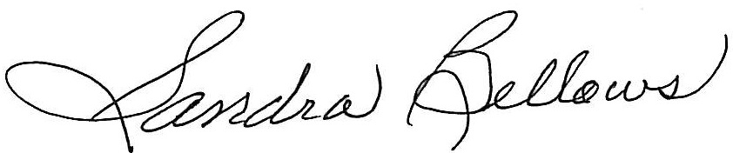
Respectively Submitted,
Sandee Bellows, Secretary

