Minutes of Library Board
March 18, 2017
8:30 am
PC Library Meeting Room
Call to order
Recognition of the Open Meetings Law Availability

Roll Call: Present: Linda Bowman, Sandee Bellows, Lisa Blecha, Pattie Rice, Board members, Lola Seitz, Librarian. Absent: Vickie Zelenka, Board member, Colleen Morehead, Librarian and Mark Sunneberg, Library liaison for City Council. Guests: None.

Minutes: Accepted as emailed

Librarian’s Report:
- Transactions, City Monthly Budget, Incoming Money & Statistics Reports - see printed forms
  - Time to renew licenses for .com and .org for further five years at approximately $200.00.
- Librarian News & Updates
In March:
- Library Madness – March 13-31.
- Librarians, Board Members & Volunteers to attended Advocacy Day in Lincoln.
- March 27 – Lola & Linda to attend Pawnee City Council to request a Proclamation for National Library Week.
- In April
- Apr 9-15 - National Library Week
  - Amnesty all week – outstanding fines will be forgiven.
  - Bookmark contest with Pawnee City Pre-Kindergarten thru 6th grade.
  - April 10 – Read-In Day @ Your Library, Foundation suppling coffee & goodies
  - April 11 – Storytime for Table Rock Headstart
  - April 12 - (PM) – Storytime for PC Kindergarten & Pre-Kindergarten
  - April 12 – (AM) Golden Sower Day, Pawnee City, Lewiston, HTRS 4th graders.
  - April 14 – Movie
  - April 15 - Get an Easter Egg at Pawnee City Public Library
  - Other week-long activities as planned.
- April 21 - CASTL held in Pawnee City from 10:00 am – 3:00 pm. Library will be closed.
- April 28 – Mary Moser & students will be doing volunteer work outside of the Library as part of Earth Day.

Unfinished Business:
- Tracie Wehrbein has agreed to do Summer Reading again. Summer Reading Kick-off will be May 17th. Theme will be “Building a Better World”.
- Because of a new individual hired to oversee the Strategic Plan Process and not knowing what that individual will be requiring we have decided to place forming a focus group on hold and instead asking Board members & Volunteers to talk up the Library when they are in different community groups.
New Business:
- Lola presented a report that PC Board currently has 28.75 CEUs for this certification period.
- Adding new Policy Changes to 1. Use of Public Library, sec H. Confidentiality of Library Records.
  - #5 ref: releasing personally identifiable information –wording is being reviewed by Scott Childers, Executive Director, Southeast Library System.
  - #6. Copying of Governmental-Issued IDs, drivers licenses, passports, Photo ID, Social Security and other Governmental ID cards, will only be done for the person who is identified on the form to be copied. A second form of identification maybe required.
- Library will be getting a student volunteer, Alex Farwell, 2 hours per week, who will work under the direction of Lola & Colleen.
- Book Sale in May will be held on 1st Saturday, May 6th as part of the City-wide Garage Sale. Hours will be from 9:00 am – 2:00 pm. We will feature Cookbooks & Jigsaw Puzzles. No matter how much material a person takes we will use the Free Will donation basis.
- Discussed the email received from Nebraska Library Commission and United for Libraries, all Trustees, Friends groups, and library directors in Nebraska have access to online United for Libraries resources. The Trustee Academy is a series of webinars to help Trustees learn about their roles in libraries. Our board does not need any hours at this time.

City Council Report – None

Adjournment
Next meeting – May 20 @ 8:30 am at the Library

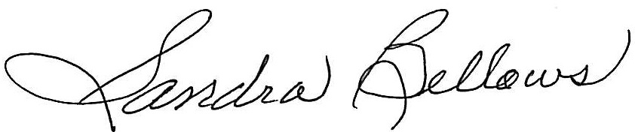
Respectively Submitted,
Sandee Bellows, Secretary

