Minutes of Library Board
February 18, 2017
8:30 am
PC Library Meeting Room
Call to order
Recognition of the Open Meetings Law Availability

Roll Call: Present: Linda Bowman, President, Sandee Bellows, Secretary, Lisa Blecha, Pattie Rice, Vickie Zelenka, members; Lola Seitz, Library. Absent: Mark Sunneberg, City Council Liaison. Guests: None

Minutes: Accepted as emailed

Librarian’s Report:
- Transactions, City Monthly Budget, Incoming Money & Statistics Reports - see printed forms
- Librarian News & Updates
In January
    - Jan 23 – Librarian(s) attended City Council Meeting to present Annual Report. Reminded members to refer to their copy of the report.
In February
    - Feb 3 - Volunteer Souper Supper, had a good turn-out and everyone had a good time; Feb 7 – Protex in to check alarm system; Feb 8 – Schendel in to spray; Feb 14 – Submitted Bibliostat to Lincoln; Feb 22 – Deb Fisher Field Office
Upcoming in March
- March 17 – Reading Classics Competition. Library will be closed during the competition. The community is invited to attend.
- March - Attend City Council to request a proclamation for National Library Week.
- March 18 – Library Board
Upcoming in April
- Apr 9-15 - National Library Week activities
- April 21 - CASTL held in Pawnee City from 10:00 am – 3:00 pm. Library will be closed.
- April 28 – Mary Moser & students will be doing volunteer work outside of the Library

Unfinished Business:
- To assist with meeting the goals for the 2017 Accreditation board members will be attending City Council meetings (they meet on the 2nd & 4th Mondays each month at 7:00 pm). No more than two members should attend at a time. Lola and Linda will go in March; Sandee will go in April; Patti will go in May & Lisa will go in August.
- As part of the Strategic Planning, a Community Focus group of five or six will need to be formed. Scott Childers, Executive Director, Southeast Library System will make two or three presentations on what the group will need to address.
- Lost/Damaged Library Materials – Moved by Vicki and seconded by Pattie to accept Policy changes to section F: FINES, #3. --- A person who fails to return or replace overdue or lost library materials may be subject to civil action, at the discretion of the Library Board, by being taken to Small Claims Court. (Refer to “Nebraska Laws Pertaining to Libraries and Library Operations” Chapter 51 Section 214). In addition, collection fees will be charged to the delinquent account. Motion carried.
- Pawnee City Library was not selected for the “Big Talks from Small Libraries “. They did receive an invitation to take part in the “Encompass Program” held for Libraries each Wednesday.
- Digitalization project has gone on-line on the company server. This feature will be available only in-house thru Library computer or Wi-Fi. Setup fee for going on-line cost an additional $500.00 which the Foundation has agree to pay in order to protect the expensive external hard drive, which is small enough to fit in a pocket.
  - Foundation is planning on having a ribbon cutting ceremony.

New Business:
- Affidavit signed by Board members verifying yearend report numbers.
- March 21 – Advocacy Day in Lincoln. Need to know who can go so Lola can get them registered.
- A letter was received from Matt Penn, Tucson AZ, asking the if Library would take part in the 2017 CATE Eclipse project; because they will need internet access. Cienega High School Students will be traveling to the Nebraska site to man their station, one of 56 stations across the path of the eclipse, to collect information on the eclipse to put the entire 90 minute eclipse on tape. The project will provide 300 special viewing glasses to the host site.
- Letter received from lawyer letting us know of a change in executor of Lucille Buman estate with an update on settlement. Apparently, there was additional funds that was unpaid so there will be an additional bequest.
- Discussed changes in Policy – Section G FEES #4, #5 & #6 - Vickie moved, Patti seconded. Motion carried.
  - #4 - Fax fees are a donation of $1.00 for the first page and $0.50 for additional pages.
  - #5 - Scan & email fees are donations as follows: $2.00,1-5 pages; $3.00, 5-10 pages; $5.00, 10+ pages.
  - #6 - Obituary and Research fees are $5.00 per request.
- Tracie Wehrbein has agreed to do Summer Reading again. Summer Reading Kick-off will be May 17th.
- Called attention to the new webpage access counter.

City Council Report – None

Adjournment
Next meeting – March 18 @ 8:30 am at the Library
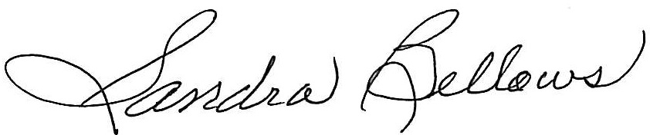
Respectively Submitted,
Sandee Bellows, Secretary

