Minutes of Library Board
September 17, 2016
8:30 am
PC Library Meeting Room

Call to order
• Recognition of the Open Meetings Law Availability

Roll Call: Present: Linda Bowman, President, Lisa Blecha, Sandee Bellows, Pattie Rice, Vickie Zelenka, Board Members. Lola Seitz, Colleen Morehead, Librarians. Members Absent: Mark Sunneberg, City Council Liaison.
Guests: None

Minutes: Accepted as emailed

Librarian’s Report:
• Claims & Monthly Budget Report
- Old Budget – Librarian explained line item overages (phone & Internet, misc. expense, maintenance & supplies, office supplies). Members of the board will talk to the City Clerk about getting a report of the Library Reserve Account that is set up at the City Clerk’s Office.
- Lola then discussed the income report.
- New Budget – was finalized at 5% increase.
• Library News for August & September
- August 1st the Book Bucks Bargain Store opened. August 8th the Summer Reading Program Pool Party was held. August 19th – 5-year Library Celebration was held. August 31 Protex Central-Fire Alarm Inspection was held. September 6th Storytime resumed for the winter. September 16th the Library will be closed for CASTL meeting in Auburn. September 21st the Book Club will resume meeting. The book will be “The Homesman”.
- October 8th the SCC Winter Quarter classes will begin with “Burlap Banner & Barnwood Reclaimed”. October 15 the Library Board will meeting at 8:30 am. October 19th Book Club will meeting to discuss “The Meaning of Names”. October 24 the SCC class on Learning Windows 10 will be held. October 29 the SCC classes on “Go Big Red Window Painting” and “Barnwood” will be held.
- November 7th the SCC class on “Star Bright” will be held.
- Lola then presented the Library statistics.

Unfinished Business:
• Jr. Clerks to work at the Library has been table indefinitely.
- Election of new officers for the Board will be elected in October. All board members are staying thru the 2016-2017 year.
- Tabled business to October Meeting – 1) Discussion on possible fees, free-will donation basis for meeting held by for-profit businesses. Would we open the meeting room to social gatherings? Where would Political meetings fit? Would we consider a cleaning or damage deposit fee? This would be different from the non-fee basis used now for Library use first, Non-profit and Governmental.
2) Look at updating “unattended child policy” to add a minimum age for the attending adult (or young adult).
New Business:
• Motion was made by Sandee and seconded by Vicki to allow the Librarians to keep the Library open on Halloween. Motion passed.
- Discussion of the Christmas Store was conducted. It will run in conjunction with the School AR (Accelerated Reader) Program. Have a few details that need to be worked out. Needing all donations for items before Thanksgiving.
- The microfiche machine is obsolete and dying. Its age makes getting new parts very unlikely. This would be all the newspapers archived at the Library which are used for genealogy research. The new computer and printer has been purchased. The board discussed what time table (all at once or in sections) to use and how to pay for the needed digitizing from the microfiche films. Vickie moved and Pattie seconded that we do the entire digitizing at once and to approach the Foundation to release, but not exceed $10,000.00.
- The next Foundation meeting will be held on October 11, 2016. All are welcome to attend.
- Beginning in July of 2017 the Library begins the next Accreditation Process.
- President Linda handed out new contact lists and new updated Bylaws (which reflect the change in meeting date and time).
- Discussed the need to have a continuing dialog concerning the outside lights of the Library. At least one light is dangling and the individual who came and looked at the problem first indicated that the lights were improper for their location and would have to be replaced. We need to get a second recommendation before anything is done.

City Council Report – None

Other

Adjournment
Next meeting – October 15, 2016@ 8:30 am

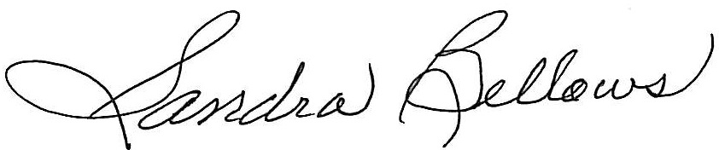
Respectively Submitted,
Sandee Bellows, Secretary

