Minutes of Library Board
8-1-2016
PC Library Meeting Room
Call to order
• Recognition of the Open Meetings Law Availability

Roll Call: Present: Board Members: Linda Bowman, President; Sandee Bellows, Pattie Rice, Vickie Zelenka; Lola Seitz, Librarian. Absent: Lisa Blecha, member; Colleen Morehead, Librarian; Mark Sunneberg, City Council Liaison.

Minutes: Accept as emailed

Librarian’s Report:
Librarian presented: Incoming Money report; Monthly Statistics; Transactions & Expenses reports, Library News & Updates – June 7th – LuAnn Brown from USDA was here to complete the Community Facility Compliance Review. June 21st – Congressman Adrian Smith held a mobile office at the Library. June 27 – Planning Commission held an Open House at the Library. Diabetic Wellness Clinics will be held every Thursday, August 11 thru September 15, from 1:30-3:30 pm.

Unfinished Business:
- Summer Reading Program ended on July 30th and will conclude with a pool party/awards ceremony on 8-8-2016 at the Pawnee City Public Pool. Will need volunteers to help cook hot dogs, monitor swimmers and clean up.
- Junior Clerks – Lola did not have good luck recruiting during the summer so will try to have students come down after school, especially if they need community service hours.
- Book Bucks Bargain Store will be open from August 1-5th. Parents are commenting on how glad they are about this store because their kids are learning math and decision skills as well as reading skills.
- Library Budget was set at a special meeting of the Library Board held on July 9th. It was then submitted to the City Council. Budget was returned for further reduction, which was done and amended budget was resubmitted. Public hearings will be held before the final budget of the City Council is submitted to the State in September.

New Business:
- Storytime for walk-in students will begin again on the first Tuesday (Sept 6) in September. The expanded Storytime for PC Pre-school & Table Rock Headstart in the morning will be schedule after Librarians have a chance to visit with the teachers. An additional session with PC Kindergarten is also be considered for in the afternoon.
- The Pawnee City Library/Foundation float entered into the Pawnee County Fair Parade took 2nd place and got on the front page of the local newspaper.
- Lola announced that an additional opportunity will be opened for individuals, groups, families, etc. to purchase a memorial paver for the front of the library. An order form is being built and will be made available at the library and on-line as soon as it is done.
- At this time it looks like the Southeast Community College will be offering classes in Windows 10, Barnwood Décor, Barnwood String Art, Burlap Banner.
- On August 19th a 5th Anniversary of the opening the new Library building will be held at the library with a program featuring honored guests, followed by a reception.
- Lola is working on a grant to pay for digitizing the microfilm library. This is a grant that developed issues last year so the grant was pulled. Lola listed a couple of different options for getting this technology in place from paying the entire cost of digitizing up front or to doing the digitizing in sections. The entire process (digitizing, computer, printer) will cost about $12,000. Lola will continue to pursue the grant. We will also pursue the possibility of funding from the Library Foundation.
- The meeting night is proving to be a real conflict to some of our Board Members and for our City Council Representative. After some discussion it was moved and seconded move our meetings to the 3rd Saturday of each month at 8:30 AM beginning on September 17th.

Council Report:
- No report since Mark was unable to attend the Board meeting.

Adjournment
It was moved and seconded that meeting be adjourned. Motion passed.

Next meeting – September 17, 2016 @ 8:30 AM

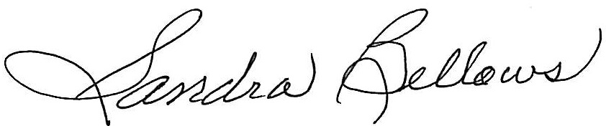
Respectively Submitted,
Sandee Bellows, Secretary

