Minutes of Library Board
7-4-2016

NO MEETING DUE TO HOLIDAY

Next meeting – August 1, 2016 @ 6:00 pm

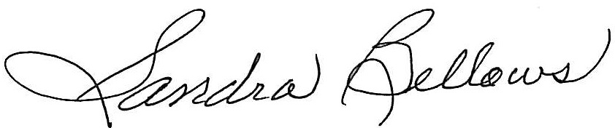
Respectively Submitted,
Sandee Bellows, Secretary

