Minutes of Library Board
December 17, 2016
8:30 am
PC Library Meeting Room

No meeting held in December due to lack of agenda items, due to holidays.

Next meeting will be January 21, 2017.

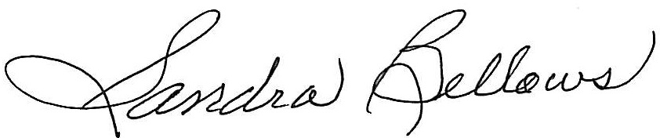
Respectively Submitted,
Sandee Bellows, Secretary

