Minutes of Library Board
November 19, 2016
8:30 am
PC Library Meeting Room
Call to order
• Recognition of the Open Meetings Law Availability

Roll Call: Present: Linda Bowman, Patti Rice, Lisa Blecha, Vickie Zelenka, Sandee Bellows, Board Members; Lola Seitz, Colleen Morehead, Librarians; Absent: Mark Sunneberg, City Council Liaison. Guests: None

Minutes: Accepted as emailed

Librarian’s Report:
- Claims & Monthly Budget Report – explained books/materials pre-pay
- Library News & Updates
  - In October
    - Storytime for Pre-School, Headstart and Kindergarten
    - SCC “Learning Windows 10” classes held; “Go Big Red Window Painting” & “Barn Wood Class” canceled
    - Library was open Halloween night – had about 95 kids & approximately 50 adults
  - In November
    - SCC Class – “Star Bright” was canceled
    - Library will be closed for Thanksgiving holiday on November 24 & 25
  - In December
    - Adrian Smith Field Office at Library
    - Christmas Store Opens on Wednesdays, Noon to 7 pm.
    - Library Board – Dec. 17
    - Book Club has moved their meeting to Wed., Dec 14. Beginning in January Book Club is moving to the 3rd Tuesday.
    - Library will be closed for Christmas holiday on December 24 & 26
- Library statistics

Unfinished Business:
- The following corrections to the Pawnee City Public Library Policy Statement were approved, unanimously, as written: Part I Section B. UNATTENDED CHILD Add to B-1. “Parents and guardians, Age 14 and older, are, at all times, responsible”. Part I Section J. MEETING ROOM USE - J-3 Groups using the meeting room are strongly encouraged to make a donation toward the use of the room. Moved by Lisa, seconded by Vickie to make changes. Part III - LIBRARY'S PHYSICAL FACILITIES -REMOVE #6 in its entirety.
- To assist with meeting the goals for the 2017 Accreditation board members will be attending City Council meetings each month. No more than two members should attend at a time. The Liberians already attend a Council meeting in February. Beginning in January 2017 we will need to make a general schedule of who can attend when.
- Wilson Lighting has repaired the current problems with the outside lights. They gave a quote to replace all the outside lights with LED, which will result in considerable energy savings. This project has been delayed until spring as it will be costly (approximately $115.00 per light x 11 lights).
- While looking at The Nebraska Historical Society Archives for research it was discovered that there are many issues of Pawnee City papers - Pawnee Press, Pawnee Chief and others - on file going back many years before the “Republican”. The Foundation has approved an additional $4,250.00 to cover the cost of adding these papers for digitization.
- The Pawnee City Christmas Store will be open December 7, 14, 21 from Noon to 7:00 pm.
- Schendel Pest has been in and done the first application.
- Lost/Damaged books –The procedure is to: 1. send out reminders, 2. then send out a letter telling them that it is a misdemeanor by state statue not to return public property (i.e.: library books). 3. If necessary the information is then turned over to the County Sheriff who sends out a letter telling them that if books are not returned and fines paid the individuals will be facing a Class V Misdemeanor and going to court.
- After a meeting between Tammy (City Clerk) and Lola (Librarian) the sales tax issue has been resolved. Beginning in 2017 sales tax will be taken out of the copies income line.
- The only SCC class that took place was the “Windows 10”. There are potential changes coming up in the SCC classes for the next quarter. There is a new person working with the Community Classes and Southeast Community College is looking at some updating in the system.

New Business:
- Lola reported that Farm Services donated $250.00 for the purchase of Ag-related books. They sent a list of books they would like to see purchased. Lola has been able to find 9 of the books, the last book is out of print.
- Lola & Colleen asked the Board to approve closing the Library for the ½ day on Saturday, November 26th. Library counts for the last few years show that very few patrons come in that day. Vicki moved and Patti seconded that Library be closed on that day. Motion passed.
- In conjunction with the Pawnee County Historical Society the Community Business Quilt is now hanging in the Library.
- Strategic Plan review – must begin working on it in July, 2017. We will need to take a good look at the Goals & Objectives.
  - Under Goal 1 - One of the first steps we will be taking will be to add a section in the Newletter, on the Website, and in facebook. Beginning in January 2017 an article called “Spotlight on You” will be added, featuring groups like the Library Foundation, the Arts Council, etc.

City Council Report – None

Other

Adjournment
Next meeting – December 17, 2016@ 8:30 am

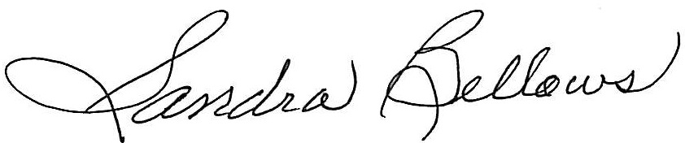
Respectively Submitted,
Sandee Bellows, Secretary

