Minutes of Library Board
October 15, 2016
8:30 am
PC Library Meeting Room

Call to order
• Recognition of the Open Meetings Law Availability

Roll Call: Present: Linda Bowman, Patti Rice, Lisa Blecha, Vickie Zelenka, Sandee Bellows, Board Members; Lola Seitz, Colleen Morehead, Librarians; Absent: Mark Sunneberg, City Council Liaison. Guests: None

Minutes: Accepted as emailed

Librarian’s Report:
- Claims & Monthly Budget Report
- Library News & Updates for Oct & Nov
  - Diabetic Workshops during Oct and first 2 weeks of Nov.
  - Storytime for Pawnee City Pre-K, Table Rock Headstart, PC Kindergarten.
  - SCC classes – Learning Windows 10, Go Big Red Window Painting, Barnwood Class in Oct and Star Bright in Nov.
- Library statistics

Unfinished Business:
- Slate for Election of officers as proposed for the upcoming year are: President – Linda Bowman; Vice President – Lisa Blecha; Secretary – Sandee Bellows. Vickie moved and Patti seconded that the slate of officers be accepted as proposed. Motion passed. All members of the Board members will be remaining.
- The Christmas Store is going forward. Any donations of items need to be in before Thanksgiving. Colleen is going to make a sign to place in the Library asking for donations from Library patrons of wrapping paper (Christmas & tissue), gift boxes (assorted sizes), ribbons & bows, and gift tags.
- The following corrections to the Pawnee City Public Library Policy Statement were made:
- Part I Section B. UNATTENDED CHILD
Add to B-1. Parents and guardians are, at all times, responsible . . . . . “Parents and guardians, Age 14 and older, are, at all times, responsible”. . . . . Sandee moved and Vickie seconded motion to make change. Motion passed.
- Part I Section J. MEETING ROOM USE
Change J-3. REMOVE -- There is no fee to use the meeting room. Groups using the meeting room may not charge admission, but may charge a reasonable supply fee to recover the cost of materials, handouts, craft-making supplies, refreshments, etc.
REPLACE with: Groups using the meeting room are strongly encouraged to make a donation toward the use of the room. Moved by Lisa, seconded by Vickie to make changes. Motion passed
- Part III - LIBRARY'S PHYSICAL FACILITIES
REMOVE #6 in its entirety. Moved by Sandee, seconded by Lisa. Motion passed.

- Beginning in July of 2017 the Library begins the next Accreditation Process. There will be several things that need to be accomplished now and during the rest of 2016 to meet the criteria of Accreditation. Lola gave the board members a copy of the “2014 Strategic Plan” to review and make suggestions, pro or con, to strengthen the plan for 2017. Each member of the Library Board will need to attend at least one City Council meeting, starting in January and continuing thru August.
- Lola & Linda presented a budget for covering the cost of completing the Digitalization Project. The Library Foundation has voted to release the necessary funds to complete this project. Betty Spitser approved using memorial funds for Cliff for this project as well. Ron Puhalla has signed the paper to release the copyright with the understanding that all use of the digitized papers remain in-house only, nothing may be used on web or social media.

New Business:
- The portion of the donation of $868.68 from the United Methodist Church youth will be used to purchase a Brothers Scan and Cut Machine ($549.00) and supplies. The use of this machine will be open to public use as well as Library use.
- The Foundation has agreed to pay to hire “Schendel Pest Control” for the Library.

City Council Report – None

Other

Adjournment
Next meeting – November 19, 2016@ 8:30 am

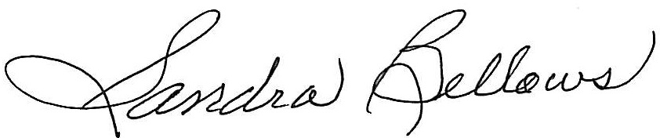
Respectively Submitted,
Sandee Bellows, Secretary

